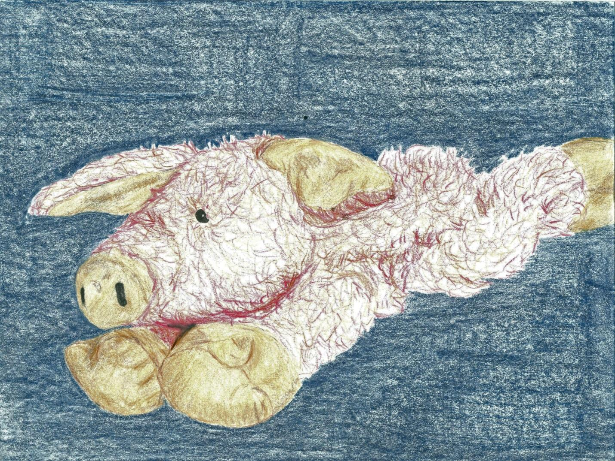

I am Lilly's Pig. I haven't always been Lilly's pig though. Once I lived on a shelf in a gift shop in a Cancer Hospital. Many people looked at me and put me back on the shelf.

Once I was handed to a child in a wheelchair and hugged so tight that I thought I would get a home. But when the child’s mother looked at the price tag on my ear she returned me to the shelf and chose a smaller stuffed animal. Another time a toddler snatched me from the shelf and drug me across the floor towards the door. Her mother snatched her up, removed me from her grasp and returned me to the shelf too. And one time a strong boy used me as a bean bag. He hurled me across the store, nailing his brother quite hard. The brother cried and the clerk asked both boys to leave the shop. She then picked me up off the dusty hard floor. She brushed me off, straightened my tag, and again returned me to the shelf.
Then one day Lilly’s Grandmother came into the gift shop and picked me up and looked at me. She turned me over and over in her hands and squeezed me softly. When I felt her finger gently lift the tag on my ear my heart sank. I was even more sad when she placed me back on the shelf and chose another animal to hold and squeeze. But she placed each one by one back on the shelf too.
When she reached for me again I began to wonder. Then she carried me to the counter and set me down with a plop. The buttons clicked and I heard a ding as the drawer flew open. It shut with a click and I was placed in a plastic bag. My journey had begun. I did not know then that I would be Lilly's pig.
It seemed like I stayed in that sack forever. I traveled for hours in that sack but I had no idea where I was going. I will never forget the look on Lilly’s face when her grandmother removed me from the sack and handed me to her for the first time. Nor will I ever forget the squeal of delight as she hugged me and spun and danced in a circle. Her joy told me that I would be loved. I was Lilly’s Pig.
That night she took me to bed and held me all night long. I was warm as we snuggled deep beneath the covers together. My floppy legs entwined her arms as she held me.
I didn’t have Lilly every night. Sometimes I slept in Lilly’s bed alone. But when Lilly was in her bed I slept with her. She played with me during the days and I went on trips with her. But when I went with Lilly I didn’t have to ride in a sack. I was tattered and torn but Lilly loved me. I was Lilly’s pig.
One day Lilly’s sister scooped me up in a rush and dumped me in a sack with some books. We rode in the car for hours before it stopped. I did not know where we were going. I sat forgotten in the sack in the back of the car. The car traveled around and stopped many times. I could hear the rush of traffic around the car. Whoosh – whoosh – as many cars passed by. But still I waited in the sack. Finally the sack was taken out of the car with me in it and carried down hallways with echoes like those of my first home. When I was lifted out of the sack I was placed on Lilly’s bed. I was still Lilly’s pig and she needed me now.
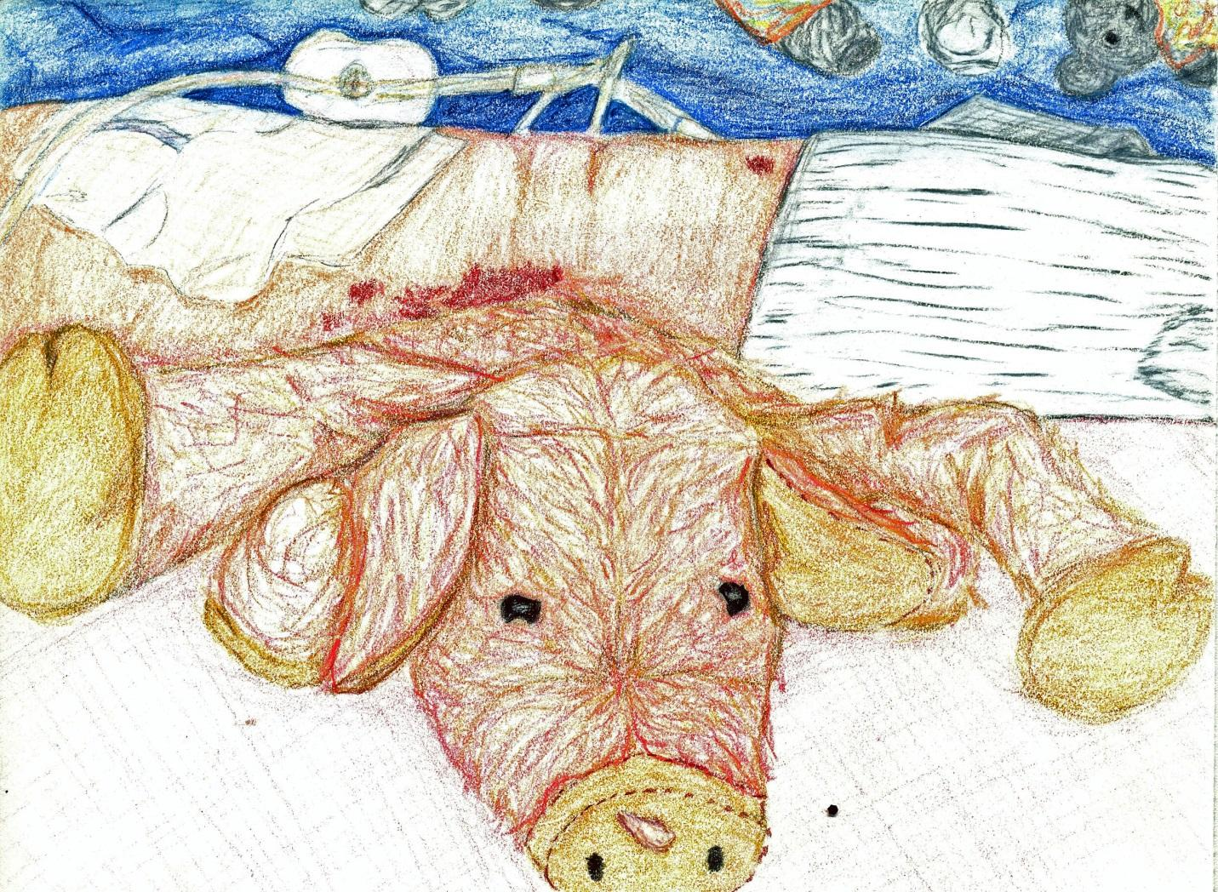
I did not know why Lilly was in this bed with the machines surrounding it instead of home in our cozy bed with the warm covers, but I was glad to be with her again. At first I just sat propped next to Lilly as she slept. When she woke briefly she held me funny and squeezed me tight. I was Lilly’s Pig and I could tell she was glad to see me too.
For days I sat in funny places on that bed with Lilly. A lot of the time I would rest under her arm and the nurses would come in and shift me from place to place with Lilly. But Lilly lay still other than that. The machines clicked and whirred constantly. There were loud beeps from time to time that told the nurses things. They would push buttons or change the liquid or the medicine that went through the IV tube when the machines would beep.
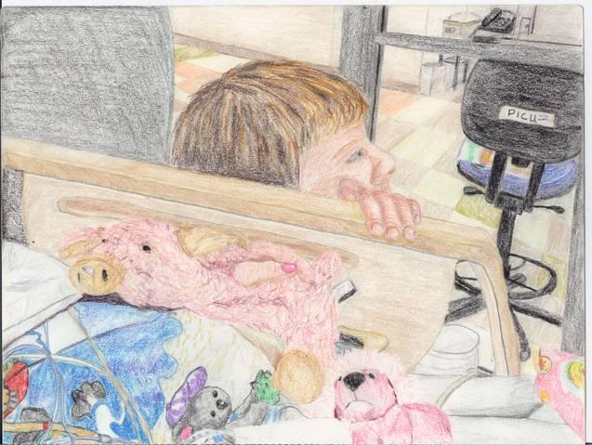

People came and went. Lilly’s mom was there a lot. Her dad was there too. Her brother came to visit and sat by her bed. He was little and he asked a lot of questions about the machines and tubes that were all over Lilly. Their mom explained that the machines and tubes were to help Lilly breathe and eat while she slept and got better. She told him that Lilly was hurt really badly but that she would be ok.

Her sisters visited too. They cried a lot. They also asked a lot of questions, but I did not always understand the answers the nurses gave. They talked to the nurses a lot, especially Rachael who seemed to want to understand everything. Grandparents, aunts, uncles, cousins, and friends came. Most brought gifts, some said prayers, but all were sad, at least at first.

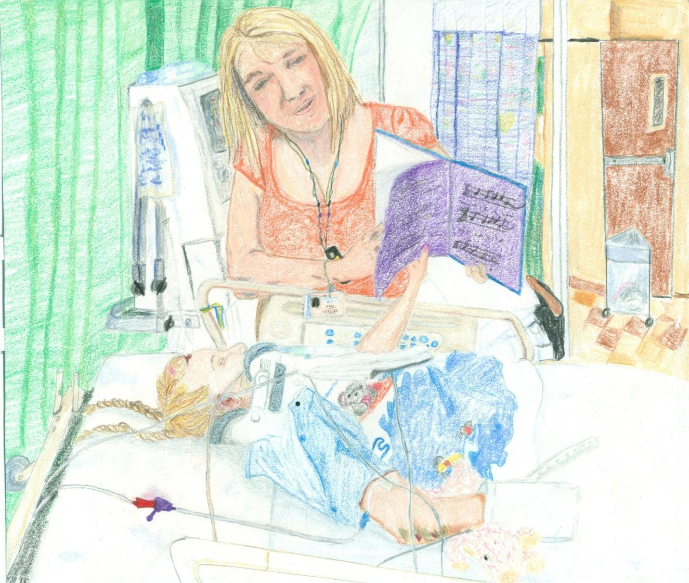

Some of the people who came were doctors or nurses. The magicians came and did magic tricks to cheer Lilly up but she was too tired. We met the music therapist who used music to inspire Lilly to move her name was Lily too. We loved her and she helped Lilly want to move.
Although Lilly slept most of the time she slowly moved more and more. One day when Lilleth the music therapist was with Lilly, singing to her and reading her stories, Lilly reached up to turn the page of a book. Everyone was so excited to see Lilly move with such purpose.
Sometimes the other side of the curtain to Lilly’s room was empty. Sometimes there were other kids in there too. Lilly was awake more but she still could not move very much. So in the bed we stayed. A small child on the other side of the curtain cried “Take it OFF now” as she struggled with her small c collar and cried big tears. “It itches” she wailed as we drifted off to sleep together. When we woke the occupants had changed. A small boy visited quietly with his mother in Spanish. The whimpering child was gone.
Then a couple of doctors came in and poked at Lilly’s Legs. Every now and then Lilly’s toes would move when they touched her foot with the tool, but the doctors seemed upset. They said something about Lilly’s legs not moving. Something was wrong with Lilly’s legs; they did not move the same way they did at home.
I was surprised one day by the hustle and bustle in Lilly’s room. Lilly’s bed began to move. Thump, thump ~ into a box and whoosh the doors closed. Only a few minutes later they opened again ~ Whoosh. Thump, thump ~ and we were off again down more hollow hallways. Thump, THUMP and I was tossed aside as Lilly was rolled this way and that in the darkened room. She was moved to a cold rigid table and a long arm moved above her. Click ~ SHHH and then a Whirr, someone told Lilly that they were taking pictures of her muscles and bones. When she was done Lilly was moved back on the bed with me. I was Lilly’s pig and I was there for her.
The next day as Lilly slept her mom, dad, and grandparents gathered in the empty half of the room on the other side of the curtain with three doctors. They talked about Lilly’s accident. I heard a lot of stuff I didn’t understand, but I heard them talking about the car hitting her and hurting her back. I could tell by the crying and the upset voices that something was very wrong. The doctors said that Lilly’s legs were not working right, she could not walk anymore. I was glad that Lilly was asleep because everyone was so sad. I am Lilly’s Pig and I do not like it when she is sad.
Lilly’s room changed several times. Usually she had a roommate or space for one. After many weeks Lilly’s room changed again. The tube that was in Lilly’s mouth was taken out, the click ~ whirr of the breathing machine was gone as it sat silent and dark in the corner. And Lilly began to talk again. Quiet and scratchy at first, then as she grew stronger she started to sound more like Lilly. After Lilly pulled the tube out that was in her nose for the third time they let her eat food again, at first only Jell-O and pudding. But soon the smells changed at meal time to real food like zesty spaghetti and garlic bread, hot steamy hamburgers and French Fries, and Juicy fried Chicken. I am glad I am Lilly’s Pig and that I was there to hang out next to her while she healed.
As Lilly moved more and more I was often set on a shelf or hung on the bedpost at the end of the bed. I had been joined by an army of stuffed toys, but it was me that Lilly chose to take with her when she was able to go in her wheelchair to therapy or to the garden outside the hospital. I was usually the one who snuggled with Lilly in her bed at night. I was still Lilly’s Pig, but sometimes I would have to share Lilly with many of the other new toys.
Lilly and I stayed in the hospital for two months. She could move now, all except her legs. She worked hard to learn to live with legs that didn’t work. She found time to start water fights with the nurses and started to act more and more like my friend Lilly again. We watched a lot of movies and still rested some, but mostly Lilly worked hard.
She had to learn how to do everything in a different way. She learned to sit up, and to get dressed and to eat. She learned how to make her wheelchair move, to turn and to stop. She learned how to live with legs that didn’t move. I was there with her to help her be strong because I am Lilly’s Pig
And then we got to go home. We rode in the car for a long time. I still sleep in Lilly’s bed, sometimes with Lilly and sometimes alone. Lilly still plays with me and takes me on trips, but it’s not the same. Lilly cannot spin and dance around with delight like the first time she saw me, but she still loves me. And although we play differently we still have a good time together. She grows stronger every day and she can do more by herself. I love Lilly and she loves me. I will always be Lilly’s pig.

