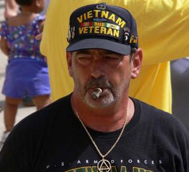
First Step Sober House

First step sober house is known for its tradition
Of saving lives that were lost to the disease of addiction
Like Father Flannigan they have a belief
There is good in every soul who seeks relief
Bill W had an idea to form a fellowship
Of people who would come together in a relationship
To help each other through the toughest time they’d ever face
Listening to each other with no judgment or disgrace
Along those same lines one man had a vision
For the hopeless, the homeless he made a decision
That rehabilitation wasn’t just for the rich
The poor should have recovery and he filled that niche
He had been there himself and he knew how bad it felt
To live with what you’ve done, the cards that you have dealt
He opened up his heart, his wallet and his home
He gave them food and clothing and a place to call their own
He helped them through the steps, to their recovery
He helped them find the way that would set them free
He knew what worked for him and he wanted to pay it forward
I’m sure he did the work he felt was required by our Lord
Sure he didn’t fix every soul who ever crossed his path
That didn’t stop him from continuing, even when he faced the wrath..

Peggy Gildon © 5/2011

