[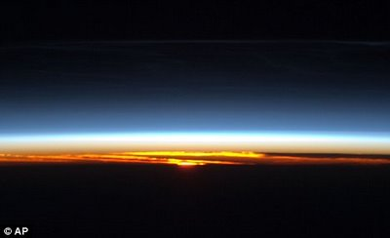](http://bp2.blogger.com/_-TskqTch9MQ/SIneoEVLSzI/AAAAAAAABbE/Ws43FP7VblA/s1600-h/article-1038214-020E154700000578-169_468x286.jpg)

**Thomas Spence**

**The Dawn Route**