I WILL STAND

As the mighty waves crash against
Me in the sea of life
I will stand

As the violent wind blows
Tearing asunder what in its path
I will stand

As sickness comes against me
And the vapors of death surround me
I will stand

As I am striped down to nothing
But the bare necessity of this life
I will stand
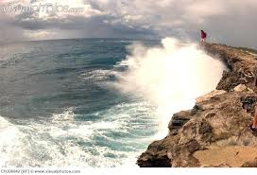
I will stand; for it is the Master
Who calms the waves and
Holds the wind in His hands
I will stand; for it was He who bore the stripes
And it is He who is victorious over death
I will stand; for He is my provider
He is my refuge and my strength
I will stand

For I hold the Masters hand

