The Mighty Hercules, A Fat Lady Sings

Flap-CopY

This is a story about embracing self-acceptance. It is a quest to unearth a forsaken desire, a journey to extinguish the impressions of yesterday. It is a passionate love story of an aging grandmother’s personal pursuit for her podium.

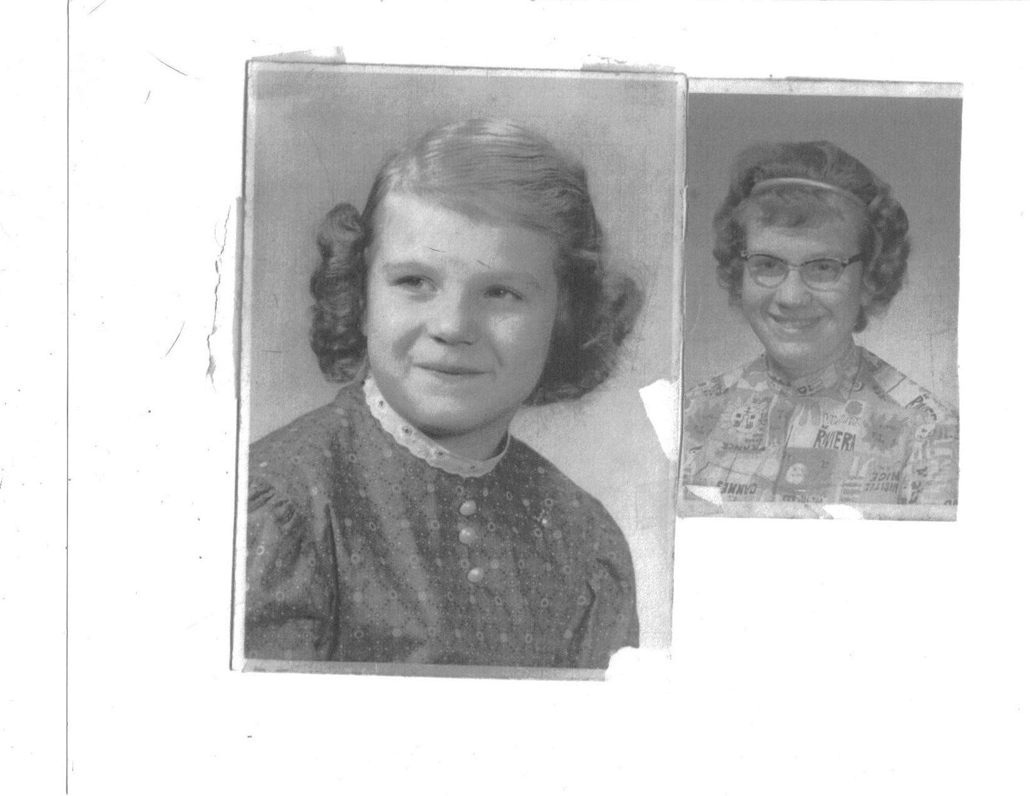
Genetically predisposed with the “fat” gene inherited from my mother’s generation of the women folk, my rapid growth came early in my life. Stricken with grief acquired from the endless heartache of being a giant life form, capacious at a young age, the skyscraper of every kid throughout school, adorned with thick glass pink framed spectacles, an ironclad permanent wave hairdo, along with my gigantic hooves, I became every child’s personal amusement park ride by the 5th grade. The non-verbal cruelty throughout a lifetime of disparaging comments from peers, associates and friends; tagged with a family move to another state as an adolescent youth of thirteen molded my intellectual composite. I endured unjust suffering. Low self-esteem, lack of self-worth, and a deficiency in confidence occupied my psychological being. I am a corpulent baby boomer. I have always been sizeable with large feet. Feet so substantial I still have difficulty locating shoes to compliment them. Feet so hefty I have spent years nose-diving to the pavement at the most precarious locations, some with serious complications and all with horrific embarrassment. Daily I can avoid the mirror, but “the shoes must go on.”

