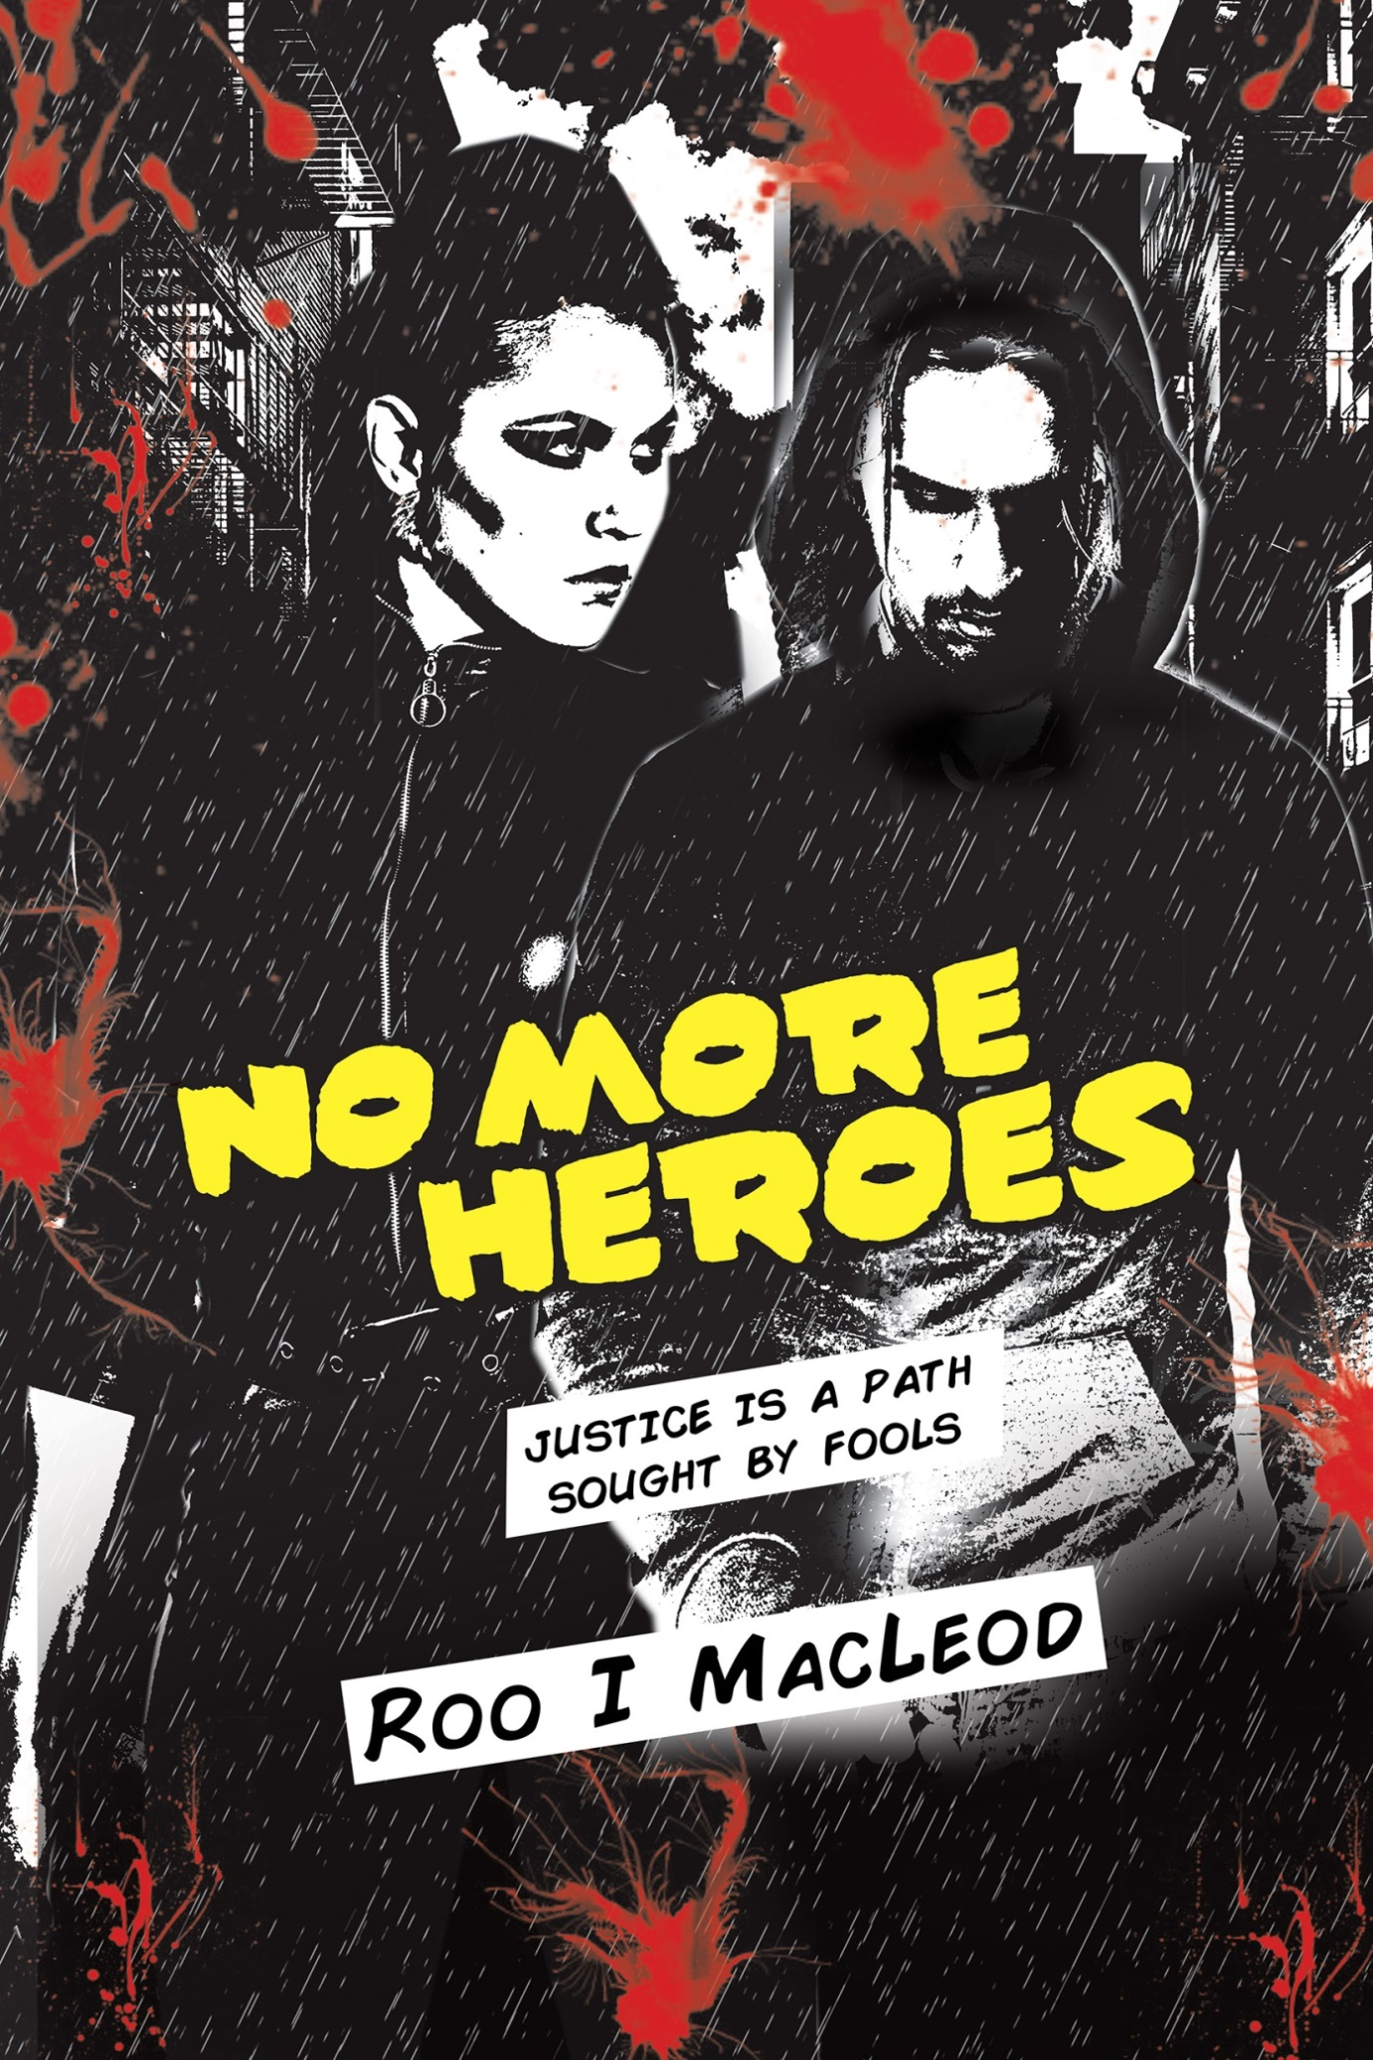
No More Heroes
A Dystopian Crime Story
By Roo I MacLeod

Chapter One

At three pm the old clock in Ostere’s town square chimed four times. The sour note of the fourth toll echoed throughout the square. No one noticed the clock’s insult to old man time as folk continued to batten the hatches against the chill wind invading from the frozen north. Smiling faces glanced at the snow bloated clouds lumbering across the sky dreaming of a white Christmas.
I blew into my frozen hands and stamped the ground with numb feet. Bugger their white Christmas, I moaned. Me and my tatty coat stood no chance of surviving December if snow dumped on our town.
The same icy breath swept Marvin into the town square. The rumbustious wind gusted through Smelly Alley. Napkins skipped into the air, canvas awnings flapped and a whirlwind of grit scurried into the gloom. Marvin’s grubby trousers slapped at his ankles and his thin summer jacket froze to his body. Raw fingers clawed at his trouser pockets and mucous seeped from his nose.
Bunkering low in my seat, my hood shrouding my face, I took a quick slug from the vodka and stuffed the bottle back in my pack. I hadn’t seen Marvin since he married the love of my life. Two years ago I ran from her rejection, nurtured my pain and wished plague and pestilence on the happy couple.
Marvin lurched forward tugging at the straps of a long black carryall as if he held the hand of a reluctant child.
Walk on by
Marvin ignored my thoughts and fell onto my warped plank, kicking the bag beneath our seat.
‘I need your help,’ he said.
He didn’t greet me or apologize for crapping on my life.
‘I’m in big trouble.’
Clouds of vapor followed each whispered statement. I didn’t want to hear his tale, but I offered him the vodka. ‘What’s in the bag?’
‘Trouble,’ he said. He leant forward, glancing left and right before focusing on my face, unable to look me in the eyes. ‘With a big T.’
His back straightened as he exhaled with a loud sigh. I tried to ignore his presence and focus on the clock as I didn’t need trouble complicating my life. Marvin scratched and fidgeted, his elbow poking and bumping me to spark my interest but I remained resolute. He jumped from the seat and pointed at the large video screen dominating the corner wall by the town hall. A short documentary featuring the plight of the penguin and the melting Artic Ice Pack they call home entertained the citizens.
‘Penguins are cool,’ he said.
‘Stop pointing.’
Short and abrupt but pointing didn’t qualify as cool.
Two lads in summer coats shivering in the winter chill caused eyebrows to rise. Two lads supping on a generic brand of vodka caused voices to gossip. I didn’t need my presence in the square becoming an issue as issues spiked the interest of the army. If the army became involved, guns, handcuffs, and bouts of torture and detention followed. Detention could be bad and detention could be forever as folk often went missing since the ‘Man’ won government. For two years I’d fought such an outcome and I didn’t need Marvin popping his ugly head above the parapet.
‘Stuff’s going down, Ben.’
What did he mean? What stuff? The army—a rag, tag bunch of conscripts—ruled our streets. And the ‘Man’—desperate to stop the rioting and looting—had issued orders for the Scarlet Scum to be shot on sight. Or maybe he referred to the Projects—the urban guerrillas pissing on our lives by taking out the electric four nights running.
Was that the stuff he thought was going down?
‘What do you want?’ I said.
Marvin, engrossed in the penguins, paced before me, knocking into a vendor setting up his food stall for the night. I replaced the vodka and pushed my backpack to the ground.
‘Sit down,’ I hissed, the source of the words hidden behind my hand.
He collapsed on the wooden seat, crossing his long, thin legs away from me. His attention now centered on a short dark man sprinkling strands of saffron into his large flat pan. A rich aroma of chicken and chorizo banished Smelly Alley from my nostrils and incited my stomach to grumble. The man looked up from his work and scowled at Marvin, wiping his hands on a cloth strung from his apron.
‘What a grump,’ Marvin said. He laughed and pointed to our right.
Sam, the snake charmer, sat against the pale trunk of a naked tree. I nodded to Sam as he retrieved a battered flute from his pocket. He smiled, waved and pointed the flute at the large cane basket sitting in the dirt. With the flute to his lips he played a lively tune cursed with off notes and a syncopated rhythm to piss off the average swaying snake.
‘They steal from each other,’ Marvin said, his attention back on the penguins.
The town square had transformed into an open-air restaurant with street performers decorating the periphery. Part-cooked carcasses, with metal poles stuck through their arse, rotated as herbs sprinkled on crisping skin. Musicians tuned instruments. Jugglers stretched and beggars searched out a profitable patch of turf.
‘They’re right old thieves, penguins are.’
I didn’t understand his point. A bag, contents undisclosed, sat beneath my seat. The trouble hounding his arse required my help, but Marvin wanted to discuss the plight of the bloody penguins. Insanity afflicted the mind in curious ways. Marvin had gone mad and she’d turned him out onto the street to fend for himself.
‘And have you seen what they do to a lost penguin? A baby one, I mean?’
We both glanced at the massive screen. The penguins waddled and flapped. I didn’t care so much about the plight of the penguin. My concern rested with Sam and his inept efforts with his flute. I don’t get snakes with their fangs and forked tongues and slippery scales and getting one to sway to music involved some degree of proficiency with the flute. Another blue note squawked and I cringed jerking my head left to focus on a group of old boy’s huddled by the betting shack. They wanted to lay a bet and shelter from the chill wind, but the sign said closed. I’d never known Bob the Bookie to close.
‘It’s not like the other penguins point out the way back home,’ he said, nudging my back. ‘No way. They peck at the wee tyke, and kick and ruck at him, and give the fluffy little fellow right old grief. But when it’s cold…’
‘Enough of the bloody penguins.’
I turned to face him, the tone of my voice causing alarm in the folk orbiting our seat. I needed to leave, to lose Marvin. I wanted to hurt him.
‘Who are those blokes?’ Marvin pulled at his tie, rolling the end up and letting it fall. ‘Why are they standing there?’
He pointed, jabbing his finger at the men. I slapped his hand before the old boys took offense. ‘Ow!’ He held his hand out the red welt evident for all to see. His attention moved from his hand back to the old boys. ‘And what is it with that wreck of a shop?’
I tried to ignore him, focusing on the clock, aware the big hand approached the hour mark, concerned it might strike the wrong time. No, my concern centered on no one giving a rat’s arse except me, again.
‘It’s obviously closed, so why do they keep trying to get in?’
I sighed. ‘They’re gamblers. They want to lay a bet. Or play the machines. Or just get out of the cold.’
‘But it’s closed.’
‘What are the odds on that, eh?’
Marvin stood and paced and scratched. The scratching alarmed me. People stepped around him, desperate not to touch his sorry scabby arse. At least he’d stopped pointing.
‘So why don’t they move on?’ He stopped in front of me and stared at them.
‘Move on where?’ I asked.
I threw my hands in the air indicating to Marvin street life offered few options unless you could magic shekels from dirt. His body flopped back on the seat, pushing his hands beneath his thighs for warmth.
‘What's going on with today?’ A petulant whine over-emphasized each word. ‘Everything’s wrong. It’s all bloody wrong.’
The big screen projected images of Ostere’s missing children and the tearful pleas from their desperate parents beseeching the kidnappers to show mercy. I pulled my thin coat tight and crossed my leg away from Marvin’s neurotic behavior and grabbed my backpack, clutching it to my chest as I shuffled across the seat, concentrating on a musical combo to our left.
Another man joined the group by the betting shop. He walked with a limp. Lots of blokes suffered limps, walking with sticks or worse. The war took the piss out of our able-bodied conscripts. The man swung his right leg with each step, his polished boots stepping heavy in the dirt. Light ginger hair, buzz-cut short complimented a red beret. He wore a mid-length, aged, black leather jacket and faded combat trousers from a campaign long forgotten. He accepted a cigarette from the group and pointed at the betting shop. The men shook their heads and huddled closer a chimney of smoke puffing from the heart of their group.
The big screen changed to the weather channel with animated fluffy white clouds covering our section of the small island. Snowflakes fluttered on the screen, assuring folk of the coming white Christmas. The ‘Man’ filled the screen lecturing and pointing and nodding, chanting the long, tired mantra ‘Good Times for hard working citizens.’
‘What?’ Marvin said. He pushed his hand through his thin brown hair before he turned back to the men by the shed. ‘What did you say?’ he muttered.
‘I didn’t say anything, but you need a drink. Or I do.’
As I pulled the vodka from my bag a large serrated knife clattered to the pavement.
‘Jesus Ben, that’s a serious knife.’
I laughed looking at the battered blade in the dirt and pulled two switchblades from my right leg pocket, a rusty cutthroat and a hunting knife from my left. Marvin shifted away from me.
‘I took this off a kid,’ I said, shoving the shiny black switchblade into his face. Marvin leant away from the blade, holding his hands out to ward off an attack. I palmed the knife as Marvin bent to pick up the serrated blade. His fingers ghosted the many nicks and serrations to the blade, before cutting the air with an elaborate swish of his arm. I grabbed his hand, stopping any further action, afraid a knife wielding man cause unrest in the square.
‘Don’t do that,’ I said. I let him feel the black switchblade. ‘Seriously, the lad I disarmed was wee and he took me for a fool. He played this stupid card trick, ripping the tourists off in Smelly Alley and I showed up and got it right like five times in a row. I was holding his money in my hand when he pulled this knife on me and threatened to gut me, but I had it off him before he could blink, shoving it right in his neck.’
I shoved my finger hard into Marvin’s neck below his jaw line and he jumped back.
‘I should’ve gutted him, but he started crying, eh?’
I fingered the rusty cut throat and smiled. ‘This nasty mother was held to my throat by a wino from the back lots near Blacky’s workshop. He thought I was sleeping so he tried to rob me but a bloke called Billy Two Guns smacked him over the head with the pointy end of a half brick. He’s small, Billy is, but he can employ a brick better than most.’
I returned the knives to their hiding places, smoothing the pocket flaps back into place. Marvin passed me the serrated blade.
‘And this one?’ he said.
I took the blade and buried it in the bottom of my backpack. ‘This one’s just for bread, but it cuts real good. Well-armed, eh?’
‘Against what?’
I showed him the half loaf of bread wrapped in brown paper and the pack of ham. ‘Folk are hungry down here and you live in the posh clouds of Upper Ostere. You’ve also spent time away fighting the good fight, haven’t you? If you haven’t got the coins, then you have to fight for the crumbs and if you don’t fight, you die.’
Marvin squirmed on his seat and wrapped his jacket tight to his body. The big screen went local transmitting images of vendors prepping their food. Cameras focused on citizens walking the worn tracks between each stall nursing drinks as they waited for a feed. A couple clad in matching coats with arms entwined sat on our seat forcing Marvin closer, our bodies touching.
‘You’ve changed,’ he said. ‘You’re all cynical and bitter.’
‘Piss off I’ve changed. I’ve spent the past bloody two years living rough. How’s your life been?’
‘Not good really. As I said –’
‘Not good? You married Linda. My girlfriend if I remember correctly, eh?’
‘You left didn’t you?’ Marvin said. He reached forward to touch my jacket, stroking my lapel. He’d always been a tactile chap. ‘You didn’t want to do your conscription and Linda didn’t know if you were coming back. We didn’t hear from you and we didn’t know where you were. You just disappeared and your parents were arrested with aiding and abetting your escape. Your dad was a four star general or something big time like that and you didn’t come back for him so we guessed you weren’t coming back ever.’
‘Piss off.’
My loud sulky tone threatened to draw attention. I still didn't know why Marvin sat with me in the square. His pale face needed a shave and his hair, already thin on top hadn’t seen a comb in an age. The dark woolen trousers wore a split across the knees, and mud caked the bottom of his scuffed shoes. The dusty jacket hung loose with the breast pocket ripped and the frayed collar of his white shirt needed a wash. He appeared to have lost weight, but he’d always been a skinny kid.
‘You still haven’t explained why you’re here,’ I said. ‘It’s been two years. You don’t turn up with a bag full of trouble and talk a load of shit without explaining yourself. I need, at some point soon, to decide whether I give a damn about your sorry arse.’
‘My life’s gone to hell.’ He pulled at the sleeve of my coat until I followed his gaze. ‘Do you know that man with the limp?’
‘No, I don’t. They’re gamblers. Old boys.’
‘He keeps staring at me. That one with the beret isn’t an old boy. I think I know him.’
‘So go and say hello, eh?’
He shook his head. ‘You don’t understand. There are bad evil men after me, and I think he’s one of them.’ Marvin turned to face me, touching me on the arm, petting away an invisible wrinkle. ‘I need you to look after the bag.’
I leant forward and peered at the large, black canvas bag beneath the seat. Chains and padlocks secured its contents. ‘What’s in it?’
‘Shit,’ he said. He shot off the seat and crouched in front of me with his back to the square. ‘I need you to get the bag to my mother.
Both hands touched my knees and I wasn’t comfortable with the intimacy.
‘They’re surrounding me,’ he whispered.
‘Who?’
‘The Black Hats. Ben, I can’t talk now, but they’ve got my father. I fear he’s dead.’
‘Slow down. Why do you think your father’s dead?’
‘I don’t know for sure, but we haven’t heard from him since we got his finger in the post.’
I turned to face Marvin, not sure I recognized my childhood mate. ‘You got a finger in the post.’ He nodded holding up his right index finger. ‘And it was your dad’s?’
He nodded again. ‘I haven’t got time for this Ben. These men are bad and they threatened to chop him up into little pieces. They threatened me too, so please remember the cane. Remember that time in primary school when I helped you out when you was in trouble.’
I didn’t get what he meant. I had no memory of a cane or Marvin ever helping me out. I remembered his picture in the society pages when he married Linda, but never him helping me.
‘The cane Principal Fletcher used for punishment. I was there for you. Please Ben. Do this for me.’
He grabbed my arm and squeezed hard, his eyes tearing up. Then he stood and strode toward the crowd gathered for the snake charming. They parted as he approached and grumbled as he pushed a path out of the square. The lid of the large basket opened and the head of a nasty looking black snake appeared, its tongue tasting the air.

