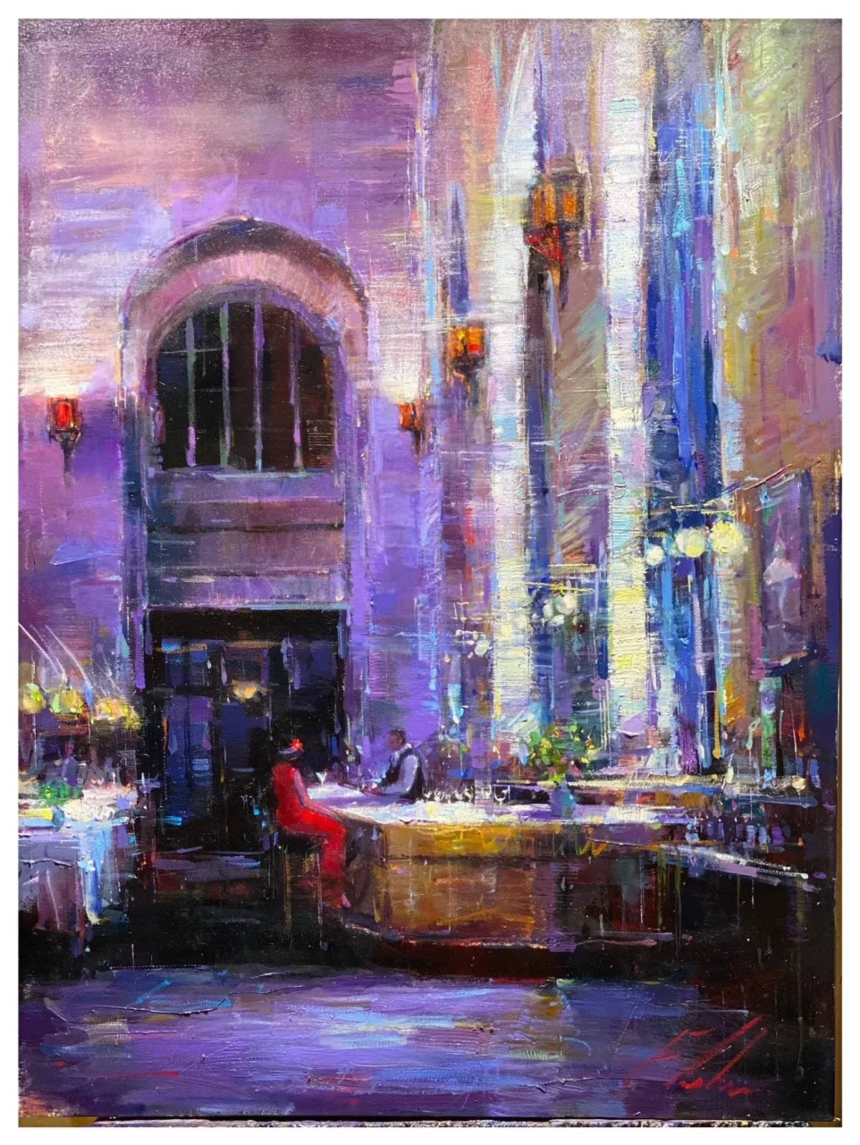
Rendezvous ~ Senryu

Your brown eyes sparkle
I’m glad that we could meet here
Tomorrow, again?

