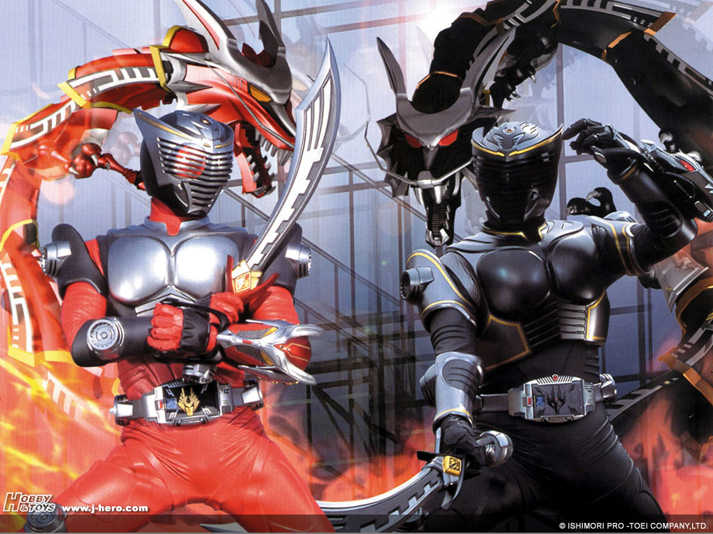[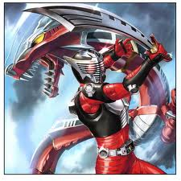](http://www.google.com.hk/imgres?q=kamen+rider+dragon+knight&um=1&hl=en&sa=N&biw=1579&bih=729&tbs=isch:1&tbnid=LCAdj1ShafkN9M:&imgrefurl=http://yusei31.deviantart.com/art/kamen-rider-dragon-knight-144310814&imgurl=http://www.deviantart.com/download/144310814/kamen_rider_dragon_knight_by_yusei31.jpg&ei=lc1sTf63O4XBcd275bwF&zoom=1&w=700&h=700&iact=hc&vpx=1187&vpy=235&dur=312&hovh=225&hovw=225&tx=91&ty=100&oei=Rs1sTdbDN4OWvAPa7v26BA&page=1&tbnh=138&tbnw=138&start=0&ndsp=36&ved=1t:429,r:16,s:0)