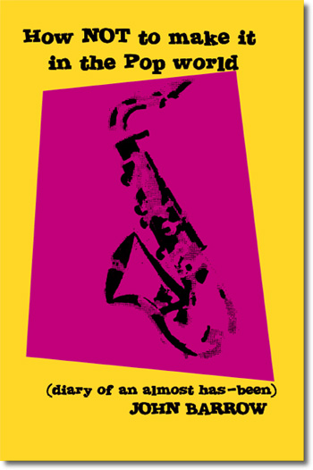
How NOT to Make it in the Pop World
(Diary of an almost has-been)
Second Edition of the book out now
In a playing career that spans more than twenty years he has been lucky enough to have played recorded and toured with world name artists that include:
BOY GEORGE / CULTURE CLUB / THE FUN BOY THREE / IGGY POP / MUSICAL YOUTH / THE SWINGING LAURELS / JERRY DAMMERS / THE CLASH / RHODA DAKAR (THE SPECIALS) / CRAZYHEAD / THE BEAUTIFUL SOUTH / BANANARAMA/ IST To order visit: http://www.trafford.com/robots/03-1791.html

